Difference between error and exception
Errors indicate that something severe enough has gone wrong, the application should crash rather than try to handle the error.
Exceptions are events that occurs in the code. A programmer can handle such conditions and take necessary corrective actions. Few examples:
NullPointerException – When you try to use a reference that points to null.
ArithmeticException – When bad data is provided by user, for example, when you try to divide a number by zero this exception occurs because dividing a number by zero is undefined.
ArrayIndexOutOfBoundsException – When you try to access the elements of an array out of its bounds, for example array size is 5 (which means it has five elements) and you are trying to access the 10th element.
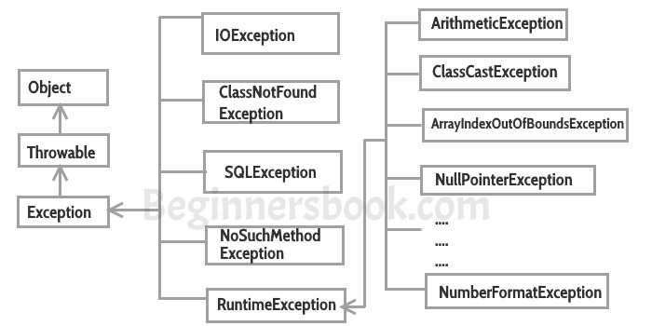

Types of exceptions
There are two types of exceptions in Java:
1)Checked exceptions
2)Unchecked exceptions
I have covered this in detail in a separate tutorial: Checked and Unchecked exceptions in Java.

Checked exceptions
All exceptions other than Runtime Exceptions are known as Checked exceptions as the compiler checks them during compilation to see whether the programmer has handled them or not. If these exceptions are not handled/declared in the program, you will get compilation error. For example, SQLException, IOException, ClassNotFoundException etc.

Unchecked Exceptions
Runtime Exceptions are also known as Unchecked Exceptions. These exceptions are not checked at compile-time so compiler does not check whether the programmer has handled them or not but it’s the responsibility of the programmer to handle these exceptions and provide a safe exit. For example, ArithmeticException, NullPointerException, ArrayIndexOutOfBoundsException etc.
Compiler will never force you to catch such exception or force you to declare it in the method using throws keyword.

Try Catch in Java – Exception handling
By Chaitanya Singh | Filed Under: Exception Handling
In the previous tutorial we discussed what is exception handling and why we do it. In this tutorial we will see try-catch block which is used for exception handling.

Try block
The try block contains set of statements where an exception can occur. A try block is always followed by a catch block, which handles the exception that occurs in associated try block. A try block must be followed by catch blocks or finally block or both.

Syntax of try block
try{
//statements that may cause an exception
}
While writing a program, if you think that certain statements in a program can throw a exception, enclosed them in try block and handle that exception

Catch block
A catch block is where you handle the exceptions, this block must follow the try block. A single try block can have several catch blocks associated with it. You can catch different exceptions in different catch blocks. When an exception occurs in try block, the corresponding catch block that handles that particular exception executes. For example if an arithmetic exception occurs in try block then the statements enclosed in catch block for arithmetic exception executes.

